**1st Grade Class Schedule**

**All Subjects**

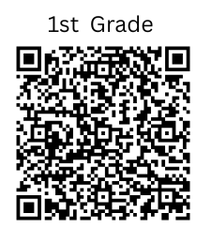

|  |  |
| --- | --- |
| **TIME** | **SUBJECT** |
| **7:30 am – 7:40 am** (10 mins.) | * Homeroom/Community |
| **7:40 am – 10:00 am** (100 mins.) | **ELA Block/ Reading/Language Arts/Writing/Social Studies**  • Fundations  • MyView  • Science/S.S. Integration |
| **9:00 am – 9:30 am** (30 mins.) | **Reading Intervention** |
| **9:30 am – 10:00 am** (30 mins.) | **Writing** |
| **10:00 am – 10:20 am** (20 mins.) | **Recess** |
| **10:25 am - 10:55 am** (30 mins.) | **Lunch** |
| **11:00 am – 11:15 am** (15 mins.) | **Independent Reading** |
| **11:15 am - 12:00 pm** (45 mins.) | **Specials** |
| **12:00 pm - 1:30 pm** (125 mins.) | **Math/Science**   * Number Sense/Number Talks * Whole Group (ReadyMath; GaDoe) * Small Groups/Stations |
| **1:30 pm – 2:00 pm** (30 mins.) | **Math Intervention** |
| **2:00 pm - 2:15 pm** | **Prepare for Dismissal** |
| **Specials Schedule**   |  |  |  |  | | --- | --- | --- | --- | | **STEM** | **MUSIC** | **HEALTH** | **P.E.** | | **11:15 am - 12:00 pm** | **11:15 am -12:00 pm** | **11:15 am - 12:00 pm** | **11:15 am - 12:00 pm** | | |